**Joe Favaloro Alerts User's Guide**

**Getting Started**

Bring up Joe Favaloro Alerts and enter your username and password and click the **Login** button.

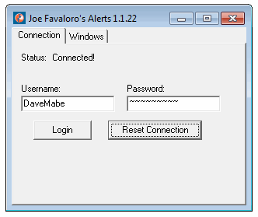

Click on the Windows tab to view the alert windows available to use.

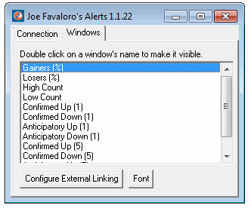

Double click on a window name to bring up the alert window.

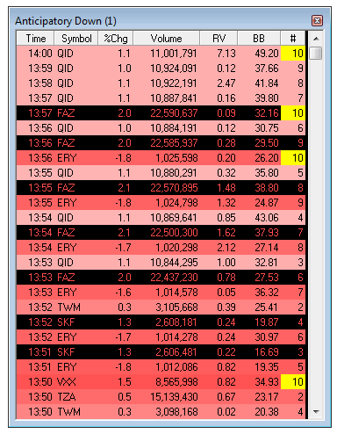

When you close an alert window or the program itself, the size and location of each alert window is remembered, so it will return to the same place on your desktop when you open it next time.

You can change the font for all the windows by clicking on the **Font** button on the main window.

**External Linking**

The application can be configured to send a symbol to an external program such as a charting or trading platform when you click on the symbol in an alert window. Click on the **Configure External Linking**button on the main program window:

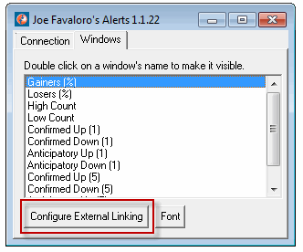

When the external linking window appears, drag the crosshairs to the program where you'd like the symbol sent.

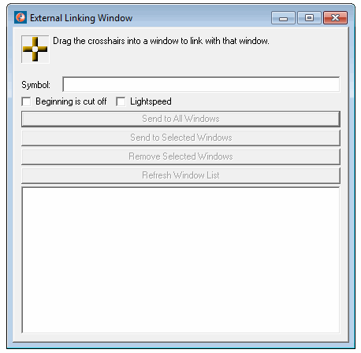

To test the external linking, click on a symbol in an alert window. Or you can type a symbol in the Symbol: text box and click the **Send to All Windows** button.

**Updating MIN VOL TODAY Threshold**

All the windows described below have a global MIN VOL TODAY threshold that can be set via this configuration page: <https://secure.trade-ideas.com/JoeFavaloro/Config.php>. The number of shares specified here controls the minimum shares that a symbol must have traded before being eligible to appear in any of the windows below.

**Available Windows**

Here is a list of windows that are available within the program:

**Gainers (%)**

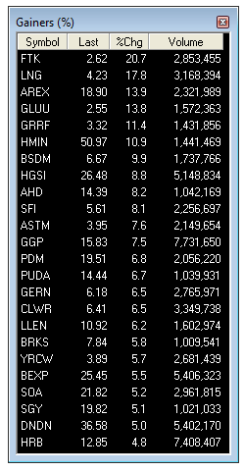

A toplist window showing the top 50 symbols in descending order by the percent change from the previous close. Once you select a symbol by clicking on it, you can use the keyboard to scroll through the list with the up and down arrow keys.

**Losers (%)**

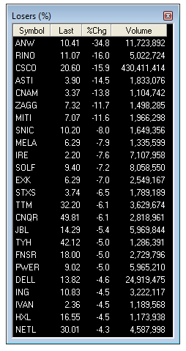

A toplist window showing the top 50 symbols in ascending order by the percent change from the previous close (biggest losers in terms of percent specified at the top of the list). Once you select a symbol by clicking on it, you can use the keyboard to scroll through the list with the up and down arrow keys.

**High Count**

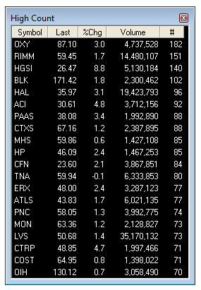

A toplist window showing the top 50 symbols in descending order by the number of new highs it has made today. These symbols must have already met the minimum volume today requirements as specified above. Once you select a symbol by clicking on it, you can use the keyboard to scroll through the list with the up and down arrow keys.

**Low Count**

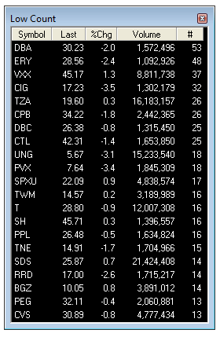

A toplist window showing the top 50 symbols in descending order by the number of new lows it has made today. These symbols must have already met the minimum volume today requirements as specified above. Once you select a symbol by clicking on it, you can use the keyboard to scroll through the list with the up and down arrow keys.

**Confirmed Up (1)**

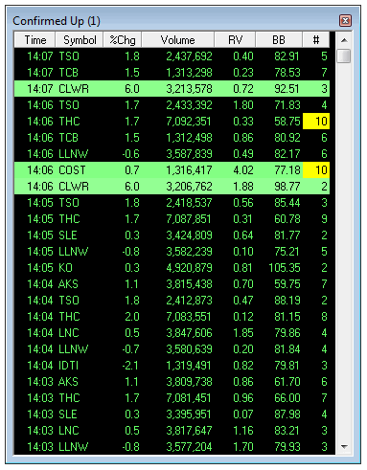

Scrolling window showing the most recent symbols satisfying the Confirmed Up strategy. The newest alerts appear at the top of the list. Each alert has a background color which can range from white to dark green. The darker the color means the higher the ranking on the Gainers (%) toplist or the High Count toplist. Stocks at the bottom of the list (rank 50) will show up with a white background. Stocks that aren't ranked will appear with a black background. Columns in this window and all windows below are:

* **Time** - local time the alert appeared.
* **Symbol** - symbol for the alert.
* **%Chg** - percent last price has changed since previous close.
* **Volume** - total volume for the day at the time of the alert.
* **RV** - ratio of current candle volume relative to previous 5 candles. These are always completed candles.
* **BB** - Bollinger Band range column with percent value.
* **Count** - number of candles in the setup at the time of the alert (current valid values are between 2 and 10). This column will appear with a yellow background when the count is 10.

**Confirmed Up (5)**

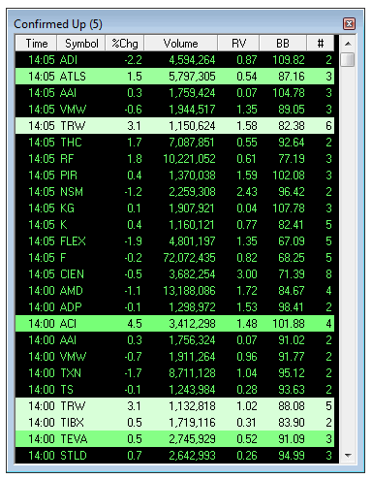

Same as Confirmed Up (1) but works on 5 minute candles

**Confirmed Down (1)**

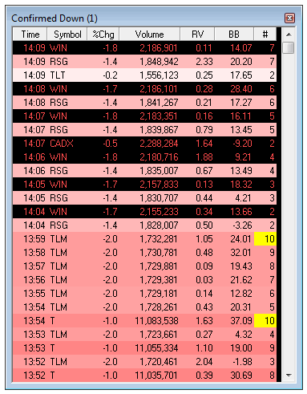

Scrolling window showing the most recent symbols satisfying the Confirmed Down strategy. The newest alerts appear at the top of the list. Each alert has a background color which can range from white to dark red. The darker the color means the higher the ranking on the Losers (%) toplist or the Low Count toplist. Stocks at the bottom of the list (rank 50) will show up with a white background. Stocks that aren't ranked will appear with a black background. The count column will appear with a yellow background when the value is 10.

**Confirmed Down (5)**

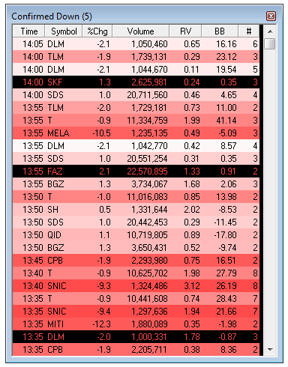

Same as Confirmed Down (1) but works on 5 minute candles

**Anticipatory Up (1)**

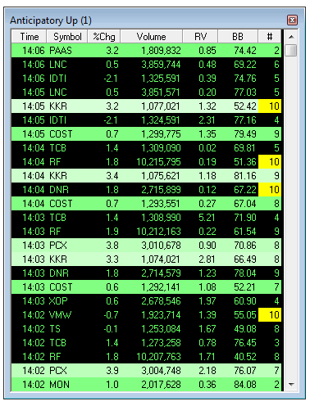

Scrolling window showing the most recent symbols satisfying the Anticipatory Up strategy. The newest alerts appear at the top of the list. Each alert has a background color which can range from white to dark green. The darker the color means the higher the ranking on the Gainers (%) toplist or the High Count toplist. Stocks at the bottom of the list (rank 50) will show up with a white background. Stocks that aren't ranked will appear with a black background. The count column will appear with a yellow background when the value is 10.

**Anticipatory Up (5)**

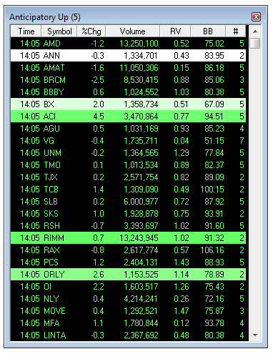

Same as Anticipatory Up (1) but works on 5 minute candles

**Anticipatory Down (1)**

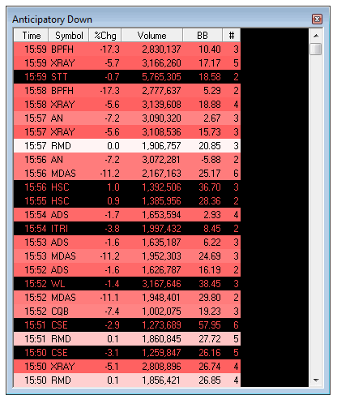

Scrolling window showing the most recent symbols satisfying the Anticipatory Down strategy. The newest alerts appear at the top of the list. Each alert has a background color which can range from white to dark red. The darker the color means the higher the ranking on the Losers (%) toplist or the Low Count toplist. Stocks at the bottom of the list (rank 50) will show up with a white background. Stocks that aren't ranked will appear with a black background. The count column will appear with a yellow background when the value is 10.

**Anticipatory Down (5)**

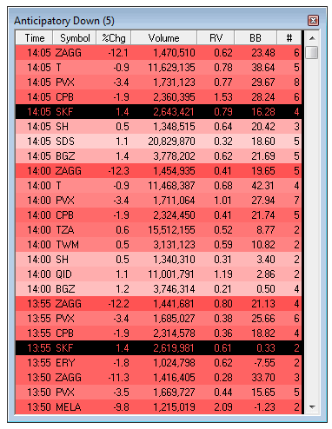

Same as Anticipatory Down (1) but works on 5 minute candles