Plans for TI Pro

TI Pro 2.0

Add the new networking tools to the network test program.
This should certainly be done first. We might even make a minor release of TI Pro with this new tool. (Don’t bump the rev number or make an announcement.)

Add code to load and save an entire layout in a file.
We originally hid that feature in the registry. To make things simpler we did not give people as many options. But a lot of people have asked for this. We’ll keep what’s already there. But we’ll also add an option to save the entire layout to a file, and another option to load an entire layout from a file.

Add code to check and see if we need an upgrade.
Same requirements as before. This was removed delayed from the 1.9 release because I was having problems with the ActiveX control. I can successfully load the required file from the server. But I was having trouble exposing the new interface to the host application. This functionality is now available in the ActiveX control. Grab the latest source code from CVS. Look for GenericNetRequest.

We will need to add a simple object to the ActiveX control which is a wrapper around “GenericNetRequest.” Then we can use that object in TI Pro to see if we need an upgrade.

Update the screen as soon as we display the splash screen.
Sometimes when we first start TI Pro there is a noticeable pause. This occurs after we display the splash screen. It appears to be network related.

The problem is that the splash screen is not really visible. It is just a gray rectangle in the middle of the screen as shown here.
In this case I used the firewall to make the problem last longer, to make it easier to take a screen snapshot. But it can happen at other times, too. It seems to happen when there’s a slow network connection.

There should be a way to force a screen update before we do anything else. I assume we can add a call to Application.ProcessMessages at an appropriate place to solve this problem.

Remove the “Global Actions” window.
This window was a mistake. It causes confusion, and adds no real value. No one would set all of their windows to produce the same sound. This made some sense for click vs. double-click. But that’s just the opposite. Why would someone want to use click for one window, but double-click for a different window.

Remove the “Global Actions” window. Remove the “global” / “custom” choices from the top of the “Alert Window Actions” window. This should always act as if the user selected “custom”.

Remove the “On Click” / “On double-click” choices from the bottom of the “Alert Window Actions” window. There should be one global setting for this for the entire application. We need to make a new window called “options”. This is the first setting, but we will have to add more to this window over time.

Open questions:
- Do we still list two different window lists? One for clicking (or double-clicking) and the other for every alert? Or do we only need one? I think we only need one.
- Where is this new global setting saved? In the local.ini? The registry is tempting. But a lot of things from the local.ini will be moving to this window.

Allow multiple actions for an alert.
Currently for each alert you have the following choices:
(This may be all that’s left on the “actions” window.) Remove the “Do nothing” option. The remaining options all get check boxes rather than radio buttons.

Make external linking simpler.
Most of our users would not be able to figure out the interface that we have. So let’s remove some of the options.

There should be no way to delete or rename a list. There should be no way to edit the list name in the GUI. You can either select an existing name, or you can select “<Add New List…>”. There should be no need to watch for the enter key, the escape key, or the exit event.

Note: Most users will not know the difference. As long as you only selected items from the list, and never tried to type, everything should look the same.

The list names should change just slightly. We still start with “MAIN LIST”. The first we one create is “Window List #2”. The second one is “Window List #3”, etc. (“MAIN LIST” is the first one, so the first one you create is #2.)

Keep the existing logic for creating names, and updating the list in the selection box. In particular, if someone renamed a list with the previous version of the software, and saved his changes, he should still see the name he created. (Rationale: That part of the code works well, so there’s no need to change it.)

I hope that we can delete a lot of the code related to the event handlers. We can make that code simpler.

Double-click on symbol list window means edit list.
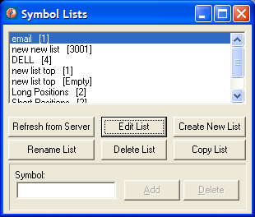
If you double click on the top part of the window (where it says “email”, “new new list”, “DELL”, etc.) nothing interesting happens. You select what’s under the mouse the first time you click, but nothing happens the second time you click.

If you double-click on a list name that should be the same as clicking on that name, then clicking on “Edit List”.

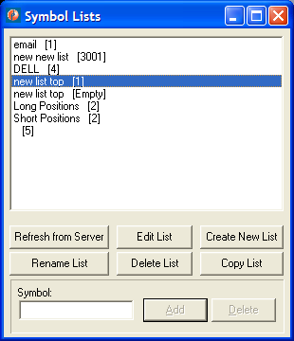
If you double click on the empty space at the bottom, that’s not very interesting. We should not treat this as a special case. Do the easy thing. I assume that if something was already selected, we will edit it. If nothing was selected, or multiple lists were selected, then we’ll ignore the request. (If the Edit List button was disabled, then we do nothing, exactly as if a person clicked on that button.)

Default colors
The default color scheme should be the light colors. This should apply to all three windows that are shipped with TI Pro. This only applies to the main TI Pro install package, not to Evo Scanner, or any of the others.

The default font should be Verdana 9pt. Again this applies to all saved windows that are part of all the main install package.

Add more status for history
Right now it’s not completely clear when a history request is complete. The easiest way is to see if the “Time Frame” menu item is enabled or disabled. Yuck!

Modify the title bar of the window to give additional information. This can be done in the ActiveX control. And it will automatically apply to other applications with no effort on their part.
- Say “FREE High / Low Ticker” for the real-time stuff, like we do now.
- Say “History: FREE High / Low Ticker” for a complete history response.
- Say “History Loading: FREE High / Low Ticker” for history in progress.

To do this right, we’d need to add another property to the ActiveX control: “BaseWindowTitle”. If I go to save the window in TI Pro, I don’t want the file name to be “History Loading: FREE High / Low Ticker”. This should always be “FREE High / Low Ticker”, as it is now.

Note: The ActiveX part of this has been changed. See revision 1.3 of TradeIdeasWindow.doc, revision 1.10 of AlertGrids.pas, revision 1.3 of TradeIdeasWindowImpl1.pas, etc.

TI Pro 2.0.7
This release includes several small bug fixes and no new functionality. This version of TI Pro uses version 4.0.1 of TradeIdeasWindowProj1.ocx and version 1.3.4 of TradeIdeasGenericConnector2Proj1.ocx.

Bug fix: Remove hotkeys from external linking window
The external linking window has some hot keys. They were added in a very recent version of TI Pro. “C” for example brings you to the current list name field, and “N” creates a new list. “D” and “R” are sometimes hotkeys, depending on which buttons are disabled at the moment.

The problem is that you can hit one of these without hitting the ALT key and they will still be hot keys. If you click on symbol and try to type, you will not be able to enter a symbol name that includes one of these letters.

Ideally these should work like normal hotkeys. If you are typing in the “symbol” field you should have to hit the ALT key to activate the hotkey. Otherwise these keys should type directly into the field.

It would also be acceptable to just remove the hot keys. In fact, since only the “C” is shown with an underline, I didn’t even know that the other three were hot keys. I never would have hit these keys, so removing the hotkeys would not hurt anything.

This bug was reported by:
From: Mark Huggett [mailto:mhuggett@qwest.net]
Sent: Wednesday, November 22, 2006 7:37 PM

Fix missing charts
The current has code a problem. If you log in as DEMO you do not have access to the charts. If you log in as paying customer, you can get the charts. This is all handled by the server. The problem is that the client caches all of the results. If you request a chart when you are DEMO, then log in, you will not see that chart.

Solution: Add a new procedure called ClearBadImages. If you call this, and there were any errors, then we clear just the errors from the cache. Each time that the GetAlertData unit attempts to reconnect, it calls the ClearBadImages.

Note: There is no easy way to clear only part of the cache. The easiest thing is to clear everything at once; we already have a procedure for that. However, this is not acceptable. If there is a bad connection, and we have to keep reconnecting, we do not want to reload all the icons each time.

A better option is to clear the entire TImageContainer object if at least one of the images in that container is bad. This is, in fact, a very good option. If one icon in a container is bad, then there is a very good chance that all of them are bad. (I don’t have the code in front of me. This is just a suggestion.)

Note: When I say “bad” I’m referring to the “isNoRetry” state. All of the other cases are already correct. “isNoRetry” means do not retry until the next call to ClearBadImages.

Now that I think about it, I think we can do even better without much effort. Each call to ClearBadImages will look for icons where the icon state “isNoRetry”. Change the state to something else. (Maybe “isProblem”, but I’m not sure.) Do not request the new icons yet. If at least one icon was in the isNoRetry state, then sent the callback to the GUI telling it that something has changed. The GUI will make another request for the icon if and when it is required.

Fix the IconDirectory property
Make this property use the new messages to the server, not the HTTP messages. This was described in more detail in an email message.

Additional Bug Fixes
- The previous version of the active X control did not work with the Chinese version of Windows XP.
- Attempt to fix TI Pro shutdown during autoupdate at startup.
- TradeIdeasGenericConnector2Proj.ocx now works with special characters like the period, dollar sign, and hyphen.

TI Pro 2.1

Recommended Order
The top one is my highest priority. Everything in black, including the numbers, is a suggestion from Leonid. My notes are in green.

6 - "Add Time Offset to the Config Window" – Important, but not as important as the items above.
7- "Consolidate the Save/Restore Layout options" – Important, but not as important as the items above.
4 - "Improve the way we periodically refresh the icons" (but it works for now in an acceptable way) – This has been an issue for a long time and no one has noticed it yet. ☺
8- "Network Test Program - Reading the Proxy Settings" – This is purely cosmetic.

Bug fix: WindowConfig format has changed
I added two new column types. This causes a problem when you save the window config with the old software and load it with the new software. The color choice is wrong, for example. We need to fix that.

Perhaps we need version “D” of WindowConfig. This would include the total number of columns in the string. For versions A, B, and C the code has to know the old value.

Note: Leonid thinks this only happens when you downgrade. If that’s true, then it’s not really a problem and does not need to be fixed. When I found this, I was downgrading my software.

Bug fix: List Name Changes
In the Alert Window Actions window, we do not always display the right list names.
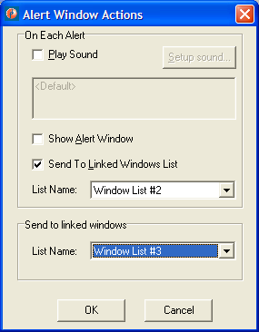
Let’s say that I change the two list names, as shown above. Then I hit OK. Thing work as expected for a while. Then let’s say that I bring this window up again. Then it will look like the picture below.
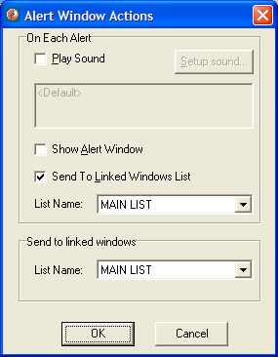
Both of the list names are wrong. We are displaying the default values. We should be displaying the current value.

Change text in Alert Window Actions window
The bottom part of the Alert Window Actions window says “Send to linked windows”. This is confusing. It should say “On double-click send symbol to” or “On click send symbol to”. Select the correct phrase each time we display that window. Select this based on what the user has selected in the options window.

Bug Fix: Resetting the Config window
Each time the user requests the Config window, the server tells the client everything that should go into that window. It took a while to recreate these controls each time, so I added some caching. The new code always updates some items, like the symbol lists, every time. Other items are only redrawn if we think that something has changed. That logic is broken and we don’t update the config window as often as we should.

The rule is that we reuse the config information as long as our connection to the server is good. If the connection is broken, we are supposed to start fresh. We don’t always do that correctly.

Reproducing the problem
If I install a new version of the server, all of the TCP/IP connections are broken at once. Each client has to automatically log in again. At this time the client should reset the config window. This does not work. (This is the ideal case. The contents of the config window are hard coded into the server. To change the contents of the window we need to recompile and restart the server. The client should detect this and expect that something might have changed.)

I can cause the same problem in a different way. I’ve asked the client to talk to a test server using the TcpIpServerAddress property. The HTTP proxy always talks to the production server; you cannot redirect it. Using TI Pro’s Options window I can switch between the direction connection and the HTTP proxy connection. This will cause me to switch between the production server and the test server. Like the previous case, this should cause me to reset the contents of the config window, but it does not.

Note: There are several different ways to reset the network connection in the ActiveX control. Not all of these are available in TI Pro. Look in “EXE Container” for a test program that will give you more options. For example, it’s possible to change the TcpIpServerAddress while the program is running.

Also check what happens when you disconnect the network cable from the client computer. This should reset the config window.

You might look at the Reset and SoftReset procedures in the Delphi code. These are called when the client software breaks the connection. I don’t know if these cover the case when the server breaks the connection, or the case of a temporary network problem.

Note: This problem is only visible when you switch from one version of the server to another. I saw this most recently when I changed AlertConfig.C from revision 1.13 to revision 1.14. I can help you set up Will with a different version of the server software whenever you want to work on this.

Symptoms
This is only to help you recognize the problem and test your solution. These symptoms should go away when you fix the underlying problem.

If nothing has changed on the server, there are no problems on the client.

If the server changes the name of an alert, the new name appears in some places, but the old name remains in other places. The new and correct name appears in the ToolTip on the strategies panel. But the old, incorrect name appears next to the icon in the list of all possible alerts.

If we add a new exchange this causes worse problems. This causes an exception. The config window doesn’t know what to do, so it displays an ugly debug window. The message in the window starts like this: “Class=EAccessViolation, Message=Access violation at address 00D32D37 in module 'TRADEI~1.OCX'. Read of address 00000000, Location=AlertWindowConfig, TConfigureAlertsForm.ReceiveAlertConfigData, "<API><CONFIG><ALE…”

Other things, like adding a new filter, do not cause any problems. The client works exactly as it should.

How it should work
If I select “Reset Connection” from TI Pro’s “File” menu, everything works as expected. This will break the network connection to the server and it will reset the config window. Note: This is not the common case. I offer this as an example of how the code should work. However, most of the time changes to the config window on the server side, and the user selecting this menu item, will be unrelated events.

I’m not sure if the previous paragraph is correct! I copied that from some old notes. Just now I tried to repeat that. Selecting “Reset Connection” cured some of the symptoms, but it seemed to create a new problem. The strategies panel was blank!

Clearly this bug is a little bit chaotic. Please be very through when you test your fix.

Related Problem
Now that I think about it, there is another way that we might see these same symptoms.

The list of alerts and filters are hard coded in the server. That’s why we don’t expect them to change at just any time. They cannot change while we are connected to the server.

Other items, like the list of strategies and the list of symbol lists, come from the database. These can change at any time. So we rebuild these sections of the config window every time we display it.

The list of exchanges should really be in the second category, like the symbol lists. This case is much less common, but this list could also change at any time. (It was originally hard coded on the server, but now it’s based on a combination of things.)

Note: The list of exchanges is much shorter and simpler than the list of alerts and the list of filters, so caching isn’t as important.

Unexpected Exceptions
We have an exception handler in the code that updates the config window. This will display any exceptions in the debug window. The code will automatically retry forever.

We should add a reset into that exception handler. If there is an unexpected exception, we should still display the error message, but we should also clear out the config window. That way, when we retry, the problem should go away. (In the case of this particular bug, it should solve the problem. In the case of future, unknown bugs, this is still a good idea.)

Note: I recommend that you add this before you fix the underlying bugs. Since this still prints an error message, you will be able to test this feature in addition to testing the real bug fix.

Other Possible Problems
Does this bug affect anything else? We have a property called the epoch. It is maintained by the networking part of the code. It is used by the symbol lists part of the code. It is similar to what we are doing with the config window. It’s worth looking at this code to see if there is a related bug.

The code is similar, but maybe it’s not the same. I don’t remember. The symbol lists might have only cared when you switch to a different user id.

Bug Fix: Checking the versions of the ActiveX controls
On some computers we do not have the correct permissions to check the version of the ActiveX control. In this case are reporting an error and the user cannot start TI Pro. This is not correct. If we cannot check the version then we should assume that the user has the correct version.

Note: We’ve seen this problem most recently with UBS. However, we know that it’s happened to other people, too. It’s not limited to UBS.

We discussed a quick workaround for UBS. We disabled the version check. That is not the long term solution that we want. Whenever possible, we should still try to check the version of the ActiveX control.

From: Leonid Lukyanchenko [mailto:softcraft@mail.ru]
Sent: Tuesday, February 13, 2007 3:00 PM
To: 'Philip Smolen'
Subject: RE: UBS ActiveX problem

Hello, Philip.

Yes, you are right.
We try to check ActiveX version in TI Pro by reading registry keys under HKEY_CLASSES_ROOT hive (function CheckActiveX called from TradeIdeas.dpr) .
Access to this hive is denied for users who are not members of Administrators group.
Probably we need to change the function and use some other mechanism.

So I see two quick solutions for UBS:

- They run TI Pro under user account which is a member of Administrators group. (In any case they have to use such account during installation of TI Pro).
- We remove call to CheckActiveX function from the TradeIdeas.dpr and build a new installation package for UBS, without ActiveX checking in TradeIdeas.exe.

I’ve tested solution 2) on my PC – first installed TIPro 2.0.8 using Administrator account, then overwrote TradeIdeas.exe with the new version (without ActiveX checking),
and then logged in as a non-Administrator user and started up TI Pro. TI Pro started and worked without problems.

Thanks.

Leonid.

Make it Easier to Upgrade
When the user starts the install program, that program should automatically shut down any running copies of TI Pro. This should work regardless of customized names for the application, where the application was installed, etc.

More details:
From: Philip Smolen [mailto:philip@trade-ideas.com]
Sent: Friday, January 12, 2007 10:02 AM
To: 'Leonid Lukyanchenko'
Subject: RE: Making it easier to upgrade

The second one sounds better because it is simpler. Of course you know more about the details than I do.

If we want to be unique, maybe the name should be “TPhilipSmolenPresentsTradeIdeasPro”. If it’s worth doing, it’s worth doing right. ☺

Thanks.

-----Original Message-----
From: Leonid Lukyanchenko [mailto:softcraft@mail.ru]
Sent: Friday, January 12, 2007 4:55 AM
To: Philip Smolen
Cc: dan@trade-ideas.com
Subject: Re: Making it easier to upgrade

Hello,

I think it's easy to implement.

I see two possible solutions:
1) Installation program will write registry key to inform TI Pro application that it should terminate.
TI Pro already has a timer (with 1 second period) that is used to check account status changes and to handle URLs. We add
additional procedure to check for termination registry key. When this key is found in the registry, TI Pro terminates.
Installation program will wait for termination of TI Pro by checking named mutex object. This mutex is created
upon startup of TI Pro and is destroyed when TI Pro terminates (now we use this mutex object to suppress second instance of TI Pro).
All necessary functions are available in InnoSetup scripting engine.
This solution requires changes on both sides - in TI Pro source code and in installation script.
2) Inno setup scripting engine has functions to find particular top-level window (HWND) by class name of the window.
Also it has functions to send windows message to particular window using HWND. We can use these functions to find main form of TI Pro
and then send to it WM_CLOSE message.Again, mutex is used to check application termination. This solution requires changes only in installation
script. One possible issue - currently our main form window's class name is TMainForm. It is possible that another application in the system
would have the same class name and will be found first instead of TI Pro. Probably, we should change the class name for main form to something like
TIProMainForm to ensure uniqueness.

Let me know what you think and which solution is better according to your opinion.
I suppose the first one is more reliable and safe, although requires a little bit more coding.

Thanks.

Leonid.

-----Original Message-----
From: "Philip Smolen" <philip@trade-ideas.com>
To: "'Leonid Lukyanchenko'" <softcraft@mail.ru>
Date: Thu, 11 Jan 2007 10:22:36 -0800
Subject: Making it easier to upgrade

>
>Hi. There's a common problem, and maybe we can solve it. People try to
>install the new version but the old version is still running. By default
>the install program shows them an error message, and gives them a chance to
>retry. But many of our users find the message confusing.
>
>
>
>I'm sure we can do better. When you run the Skype install program, the
>current version of Skype shuts down automatically. I think we can do
>something similar.
>
>
>
>Does that sound hard? I know that we use the registry sometimes for one
>copy of our program to talk to another. And the install program can set
>registry values. You know a lot more of the details than I do.
>
>
>
>Of course, this should shut down all copies of TI Pro, regardless of which
>directory it's running in, or the value of RegistryKey. It probably
>shouldn't ask if you want to save your layout, as that will only confuse
>people.
>
>
>
>Let's add this to the requirements for TI Pro 2.1. Let me know if you have
>any questions or comments. Thanks.
>
> _____
>
>From: Dan Mirkin [mailto:dan@trade-ideas.com]
>Sent: Wednesday, January 10, 2007 10:07 AM
>To: phil@trade-ideas.com
>Subject: happy birthday
>
>
>
>This is on the topic we talked about before and at the meeting. I get this
>a lot more than you think.
>
>
>
>[09:51] rnorine21: can someone help me download the new 2.8 version?
>
>[09:53] rnorine21: I get to the instal window and then an error occurs while
>trying to replace the existing files: DeleFile Failed; code 5 Access
>denied.
>
>[09:53] SupprtTradeIdeas: make sure
>
>[09:53] SupprtTradeIdeas: that your TI application is closed when you are
>downloading new one
>
>[09:54] rnorine21: k
>
>[09:54] rnorine21: thanks that worked
>
>[10:05] SupprtTradeIdeas: glad to help
>
>
>
>
>
>Dan Mirkin
>
>Senior Managing Partner
>
>Trade Ideas LLC
>
>www.trade-ideas.com
>
>760.434.4952 Direct
>
>858.922.9420 Mobile
>
>
>
>
>

Color of OddsMaker Button
There is a button on the alerts window that usually says “run.” When you hit it, you start the OddsMaker, and the button changes to say “stop.”
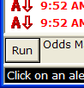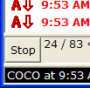
Change the color of the button to green when it says run. Change it to red when it says stop.

The purpose of this change is to make the oddsmaker more visible, so more people will try it. It’s advertising, nothing technical.

Make it look good. If you’re not sure, you can send us some samples.

Automatically Clear the Window After Reconfiguring it
When you create a new alert window, it is initially blank. (When you switch from history to real-time, you are in the exact same state.) At this point we try to fill the window in two separate ways. Of course, we look for real-time data. But we also request “short history”. We will look back in time for the most recent alert that met our criteria. The idea is that we don’t want to display a blank window because it might confuse a user.

The alert window has a “clear” option. This will remove all alerts from the window. But it will also set a flag in the window so we do not request short history. We only request real-time data. (I forget the name of this variable, but it an enumerated type with at least three values.)

Currently when we reconfigure the window we do not remove the previous alerts from the window. We need to change that. We need to remove all alerts from the window when the user reconfigures the window. This applies to the “Configure…” option and the “Collaborate…” option.

Note that this should not work like the “clear” option. This should work like switching from history mode to real-time mode. We need to configure the window in the right way so that we request “short history” and real-time data.

Note: This change exists entirely in the ActiveX control.

Allow Exclude Lists and Single Symbol Lists
We need to add more options to the configure alerts window. The config window should look like this:
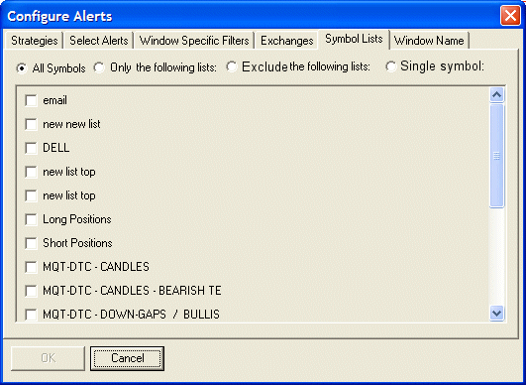

When you select “single symbol” the config window should change to look like this:
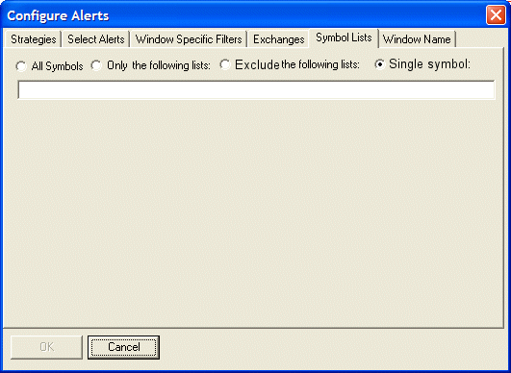
The window will change back when you select “All Symbols” “Only the following lists” or “Exclude the following lists”.

Note: These changes will be implemented in the ActiveX control, not in the main body of TI Pro.

Sending data to the server
When the user hits okay, the client will need to send a new property name to the server. This is based on which radio button the user has selected. The property name is “EntireUniverse”.

Name on radio button | Value to send to server
All symbols | “1”
Only the following lists | Empty string
Exclude the following lists | “2”
Single symbol | “3”

In the case of “only the following lists”, the client needs to send a description of the selected lists. This has not changed from the previous version. Keep that code as is.

In the case of “exclude the following lists”, send the selected lists in exactly the same way as in the “only the following lists” case.

In the case of “single symbol” the client will need to send additional data to the server. Set the “SingleSymbol” property to the value of the symbol.

Do not send the list of selected symbol lists if the mode is “all symbols” or “single symbol”. Do not send the value of the single symbol unless the mode is “single symbol”.

These properties all refer to the URL encoded string that we are building from the various fields of the config window.

Note: This format may appear rather odd. It was based on several things. It had to be compatible with older versions of the software. And it had to be compatible with the HTML version of the config window. This format is completely different from the format used to receive the same data from the server.

Note: If the user requests “single symbol” and does not specify a symbol, the server will automatically convert that to “all symbols”. If the user requests “only the following lists” or “exclude the following lists” but does not select any lists, the server will automatically convert that to “all symbols”. The client does not have to worry about these cases.

Note: When the server sends this string back to the client, the format is slightly different. If you select “Collaborate...” immediately after you hit okay, you will see exactly the string that you created. If you wait for a very short time, “Collaborate…” will show you something slightly different. The best way to test this new feature is to hit the OK button in the config window, then display the config window again. Except as described in the previous paragraph, the symbol lists tab should look the same.

Receiving data from the server
When the client displays the config window it requests data from the server. The server tells the client the structure of the window, i.e. what check boxes and text entry fields to display. It also sends several samples and the user can choose from these. The structure part of the message is not changing. But the server is now sending additional information in the samples.

In the old code, the client would check each sample for a node called “SYMBOL_LISTS”. The server now sends additional information in this node.

The SYMBOL_LISTS node will contain a property named “MODE” which corresponds to the radio buttons on the symbol lists tab of the config window.

Name on radio button | Value sent from server
All symbols | Empty string
Only the following lists | “only”
Exclude the following lists | “exclude”
Single symbol | “single”

Note: Be sure to use the FindXmlProperty function to read this property. In the case of “all symbols” the SYMBOL_LISTS node probably won’t exist at all. That function will correctly search for a property, return a default value if a node or property does not exist.

Note: The old code would count the number of symbol lists, and use that the set the initial state of the radio button. Remove that code. Set the radio button according to the MODE property and nothing else.

In the case of “only” or “exclude” the server will say which lists should be checked. This works just like in the old code.

In the case of “single” the server will set an additional property of the SYMBOLS_LISTS node. The “SYMBOL” property will contain the initial value for the TEdit control.

Note: When this goes into beta, I need to notify dfenstemaker@msn.com. He asked on 4/2/2007. Done. Sent him a very early beta release on 4/15/07.

Add Flip Option to the Config Window
We need to add a “flip” button to the configure window. This should be lined up with the OK and Cancel buttons. It should be on the far right of the window.

The flip button will change the alerts so all the “up” items become “down” and vice versa. The effect is like flipping a stock chart over, so the lowest prices are on top and the highest prices are on the bottom.

The result will be the same as if the user manually switched all of the alerts and filters by himself. That is to say that the message we send to the server does not change.

The server will send us additional information.

Each alert will have an additional value associated with it. This is a string and we will call it the “flip partner”. When the user hits flip, we will create a new variable, to hold all of the new values. Then we will go through each of the new values, and look for the flip partner. Lets’ say that “RU” has a flip partner of “RD”. (Running up / Running Down). When we get to RU, we will copy the values from RD in the original list in the slot for RU in the new list. So if the user checked RD and gave it a quality of 2 before he hit flip, then we will check RU and give it a quality of 2 after the flip.

Example: “<NHP DESCRIPTION="New high" FLIP="NLP" QUALITY_NAME="Days, i.e. 52 week high = 365" />” This says that the new values for the NHP alert should be copied from the old value of the NLP alert.

In some cases nothing is specified for an alert’s flip partner. This is the same as specifying the empty string. In this case, the alert is its own flip partner. We will copy the alert’s settings directly from the old variable to the new variable. The user won’t see anything interesting; the alert just won’t change.

Example: “<ML DESCRIPTION="Market locked" />” This does not list a flip partner for the ML alert. So we copy the old value for ML and use it at the new value.

Note: If RU has a flip partner of RD, then it’s probably true that RD has a flip partner of RU. However, you should not count on that. The algorithm listed above will work well even if the list of flip partners does not make sense.

The window specific filters are slightly more complicated. Each on will have a flip partner, as with alerts. However, each one also needs a “flip rule” to give it additional instructions. The rules are described below.

Name | Description
(empty string) | This item stays the same. Whatever was in the field before the flip will remain there after the flip. Ignore the flip partner.
- | Copy the value from the flip partner, but negate it. For example, if min up days was 7, then max up days will become -7.  To format this properly (to avoid “--7" for example) we should always try to make this a number, then negate the number, then convert it back to a string. If this was not a valid number, then put the empty string into the new field.
+ | Copy the value from the flip partner unchanged. Ordinary string assignment is fine.
% | Assume the source is S and the destination is D. D := 100 – S. For example, if the min position in the Bollinger bands was 10, then the max position in the Bollinger bands will be 90.  As with “-” we need to convert to a number and back. If the input is not a valid number, then the destination becomes the empty string.
. | Assume the source is S and the destination is D.  If S < 0 or S >= 1 or S is not a valid number, then D := ‘’  Else If S = 0 then D := 0  Else D := 1 – S  This will be used for the decimal filter.
/ | Reciprocal.  Assume the source is S and the destination is D.  If S < 0.00001 or S is not a valid number, then D := ‘’  Else D := 1 / S  Do not use scientific notation. Use a fixed format with 5 places after the decimal point.  This will be used for the put/call ratio filters.
(anything else) | Treat this like the empty string. Keep the value exactly as is.  Presumably there was a new type of rule added on the server side. Presumably we have and old version of the client. Or this could have been a bug on the server side. Either way, we gracefully ignore this instruction.

Example: “<MinBB DESCRIPTION="Min Standard Deviation" FLIP="-MaxBB" TYPE="D" UNITS="Standard Deviations" />” This says that the new value for the MinBB filter should come from the old value for the MaxBB using the “-“ rule described above.

Example: “<MinVWVP DESCRIPTION="Min Volatility" TYPE="D" UNITS="%" />” No flip partner is described in this entry. See the empty string rule described above. The new value of the MinVWVP filter should be exactly the same as the old value was.

Note: The recent changes panel should look exactly like it would if the user made all of these changes on his own. Report a change to that panel if and only if the value was actually different after the flip than it was before the flip.
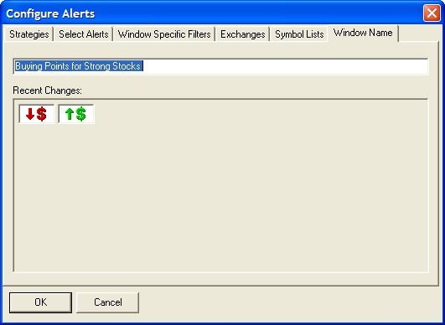

Note: The web site will be done first as a prototype for the ActiveX control. The web version is slightly different because the flip function is attached to the alert window, rather than the config window. But the rules are exactly the same.

Note: These changes will be implemented in the ActiveX control, not in the main body of TI Pro.

Notes on the decimal point
The server always expects to see a period as the decimal separator. The user’s locale settings should not be a factor in this. We know that some users have the comma as their decimal separator on their machines. That caused problems in the past because the client and the server were inconsistent.

When we convert something to or from a number, in the rules listed above, we always need to use the period as the decimal separator.

Is this setting stored in a global variable or something? It would be nice to change this value for the entire ActiveX library. The value should stay the same for the host application and the rest of the computer. That seems like it would solve the problem once and for all.

Notes on the thousands seperator
On the web site we always insert a thousands separator. For example, if the user says the max price is “10000.00” in the config window and hits “Accept Changes”, he will see a max price of “10,000.00”. The version with the comma appears everywhere on the web.

We also allow the user to enter a number with a thousands separator on the web. If the user enters “10000.00” or “10,000.00” we treat them both the same.

We decided to go a different way with the ActiveX control. We still allow the user to enter a number in either format, but we always display the without a thousands separator. Currently the conversion is done on the server side.

For now I think it is acceptable to completely ignore the thousands separator. This is slightly inconsistent. But I can’t imagine that anyone would think to type in a value like “10,000” then immediately hit “Flip”.

I never used the thousands separator on the ActiveX control because I didn’t like it much. When we added that feature to the web, we didn’t think about people with different locale settings. It’s caused more problems than it has solved. Also, there’s no reason to make the ActiveX library any more complicated than it has to be.

Add Trader’s Paradise Mode
We want a way to make our software look more like http://www.tradersparadise.com/. In particular, instead of scrolling, we just go back to the top each time and overwrite the old alerts.

The scrollbar will go away. By default the vertical scrollbar will go away. The horizontal scrollbar will appear and disappear as required, as it does now. Of course, the user can change the direction of the data. In that case the horizontal scrollbar will always go away, and the vertical scrollbar will appear and disappear as required.

Note: The use will never see the phrase “Trader’s Paradise”. That’s just a placeholder until I can come up with a better name.

Note: We do not need the white line that fades to grey. We already have the age column which is better. We do not want the odd font, or the way that the columns do not line up. We do not want the colorful thing at the bottom of their window.

Do we want to invert the last one? That’s not clear. In particular, if the user has selected patterns, that wouldn’t work. For now let’s say that we do not want to invert the last alert, even though I might change my mind when I see it.

Note: This mode is completely incompatible with history. If someone is displaying history, and they have selected Trader’s Paradise mode, we will temporarily ignore that mode and display things in the normal way. When they return to real-time mode, they will see the history again.

Note: The sortable modes, described below, also conflict with this mode. The GUI for selecting modes is not clear yet. The user will probably get a choice between normal, Trader’s paradise, and sortable.

What happens if the user resizes the window? For now, let’s choose whatever option is the easiest to implement.

Note: These changes will be implemented in the ActiveX control, not in the main body of TI Pro.

Add Sortable Modes
Take a look at TI Lite: http://www.trade-ideas.com/ForDevelopers/TradeIdeasLite/ We want to copy two features from this program into the ActiveX library.

We want the ability to overwrite one alert with the next. If the first alert is for the stock DELL, then we put that into the window. If the second alert is for MSFT, we add this alert to the window, which will now display two alerts. If the third alert is also for DELL, then we delete the first DELL alert at the same time as we add the new alert. We always use the symbol field to overwrite alerts; the user cannot select a field.

We want a way to sort the list of alerts. By default we put the most recent alert on the top. However, the user can sort by any column.

Currently the window will try to scroll intelligently. If you are looking at the most recent data, as new data is added it will push the old data down. However, if you scroll to the middle of the data, the scrollbar will follow whatever is in your window. That feature has no meaning in this mode. That feature should be disabled. The scrollbar should not move unless the user moves it.

This mode will need its own data structure. The way we store alerts right now is not at all appropriate to this mode. When the user switches modes, we can erase all old alerts, if that makes the code easier to write. (We don’t expect people to change modes very often, so that’s just not an important case.)

We will still maintain a limit of 1000 symbols. (I believe that’s a constant in the code right now. If not, it should be!) However, we will now use the sort order to determine which alert to throw away. Whichever one was on the bottom goes away. (Again, I’m talking about the default configuration where the new alerts are on top. If the user reconfigures the direction of the display, that doesn’t change which alert gets thrown away.)

History mode should be consistent with real-time mode. That is to say that if you have one window open all day, then you duplicate that window, and request history in the new window, it should look similar to the first window.

Historical data comes from the server with the most recent first; real-time data comes in the opposite order. The implementation of history should be obvious. You still need to a fast way to see if we are displaying a particular symbol. For real-time data, if we are already displaying a symbol, then we replace the old alert with the new alert. For historical data, if we are already displaying a symbol, then we ignore the new alert.

The tricky part of historical data will be requesting more. If someone selects “more” from the menu, that should not clear the screen. We should continue to merge the new data in with the existing data. We should disable the more option if the server tells us to (like we do now) or if we have already filled the screen will 1,000 items. When we request new data, we will always request 1,000 items. (There is a way to request less, but it does not apply to sortable mode.)

Note: These changes will be implemented in the ActiveX control, not in the main body of TI Pro.

GUI for New Display Modes
This is a very rough sketch.

Each alert window can select the display mode. Add a menu item under the “Colors” item, above the “Show all panels” item. This item will be called “Mode” and it will be a sub menu. Items will include:
- Newest First (the way we do it now)
- Write Over (trader’s paraside)
- Group and Sort By
  - Time
  - Symbol
  - Quality
  - #
  - Etc.
Each of these can have a radio button next to it. The default (in case a window was saved before we had this option) is to .

Notice that we don’t say ascending or descending. We already ask for the direction in a different place. It would be redundant.

This setting will be stored in the window’s WindowConfig property.

Note: This change will be in the ActiveX control. People who are not using TI Pro should be able to see the change. The local.ini files for different install packages may change. We will change TI Pro only by adding the default settings to the options window.

Add Time Offset to the Config Window
There is a property in the ActiveX control which allows you to change the timezone. By default we use the time zone from the end user’s computer. But you can enter a number of minutes to add to the time, if you want to show the time in a different time zone.

Currently the ActiveX control (version 4.0) does not do a good job with this. It displays the time correctly in the alert window. But some other places, like the request history dialog box, do not use this yet. We need to fix the ActiveX control first, before we add this option to the TI Pro options window.

The first part of the task will be to identify all places where we display the time in the ActiveX control.

Consolidate the Save/Restore Layout options
In version 2.0 we added an option to save and restore a layout from a file. We kept the options to save and restore from the registry. That seems redundant. I’m not putting this requirement into TI Pro 2.0 because some of the details are not clear yet.

On a related note, I find it annoying to have to use the confirm window every time I exit the program.
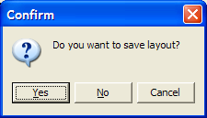
But some people like this. So it needs to be an option.

I like the way we handled this in a previous program. The user had several options.
- When you exit the program, where do you save the layout? This should be a filename.
- When you start the program, what layout do you load? This should also be a filename.
- There should be an easy way to make the first two items the same. That gives a result similar to what we already have, where you restart from where you left off. However, there are other ways to configure this.
- Another option says what do to when the program exits: Always save, never save, or ask. “Ask” means what we do now.
- We need decent defaults. By default we load the file DEFAULT_LAYOUT.til on startup. On exit we save to the same file.
- There is no way to save to the registry any more. That option is removed from the menu.
- When a person first upgrades, we read the old layout from the registry and save it to DEFAULT_LAYOUT.til. (This process should be completely transparent to the end user.) This only applies to old users. We will generate a layout from the saved windows directory, just like we do now, for new users.
- There is no other way to read a layout from the registry. That option is also removed from the menu.
- Each individual layout is saved to a file, but the rest of the information is saved to the registry.

Notes on the GUI
Here’s a very rough sketch of what the new panel for the options window should look like. I’m sure you can make it look better.
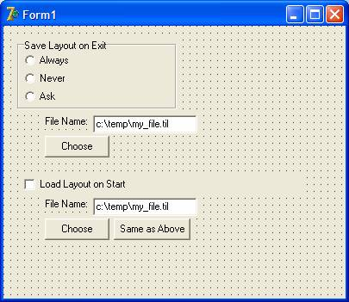
- You can type or copy and paste to fill in either file name.
- The top “Choose” button brings up the standard save file dialog box. Do not show the dialog box that warns you about overwriting a file. (I forget the name, but I think that’s a standard Delphi option.)
- The bottom “Choose” button brings up the standard load file dialog box. The user should be allowed to select a file that does not yet exist. (Again, I think this is a standard Delphi option.)
- I don’t like the word “Choose”. What do similar buttons say in other programs?
- “Same as above” copies what is in the first text box into the second text box. This does not do any long term linking, or anything else.
- I don’t think that any of the controls is ever disabled. I imagine that we save the file names even if someone temporarily turns off the load or save.

Bug fix: Height of OddsMaker panel
Note: I fixed this bug.

See how the second line in the oddsmaker is cut off? There is special logic that tries to avoid this. It runs every time that you resize the panel. Sometimes I see this bug when the window is first created. I assume that we are not running this code when we first create the window.

Note: There are several things that cannot be done in the constructor. Certain things, like asking for the height of a font, require that the object have a parent. (And that object must have a parent, etc, all the way up to the TForm.) I created the TAlertPanel.SetParent method to handle these cases.

I do not know how to reproduce this in TI Pro. I’ve seen it, but I can’t make in happen on demand. However, this bug is easy to see in Project1.exe in the Exe Container directory. Just start the software and look at the alert panel on the left.

Misc
- Several new features added to the config window.
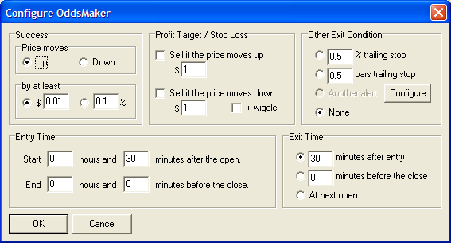
- I changed the algorithm for drawing the age column. It now looks better in more cases.

TI Pro 2.1.4

Below are changes that were included in version 2.1.4.

Bug Fix: Select & Focus Window Name
In the Configure window, when we automatically show the “Window Name” panel, the window name field should be focused and the contents should be selected. This makes it easy to change the window name, especially if you are using the keyboard instead of the mouse.

This is how it worked in version 2.0. It was broken in version 2.1.

Bug Fix: Socks Proxy Password
I found the following code in SimpleHttpRequest.pas. It looks suspicious.

FHttpCli.ProxyUsername := Instance.ProxyUserName;
FHttpCli.ProxyPassword := Instance.Password;

It seems like password for the proxy server should come from a different place. This looks like the Trade-Ideas password. My guess is that Instance.Password should be replaced by Instance.ProxyPassword. But this needs further investigation.

This is a fairly obscure feature. I’ve only done very limited testing with proxy servers. It’s possible that no one has ever used it.

Make the current direction clear
Currently, the menu does not show you which direction you are going. You can easily select a direction. But you don’t know the current direction. That can get confusing if you want to flip things over and go the opposite direction. I don’t know how I missed that before. (It appears that it worked at one time. I’ve seen pictures and videos of it working. All of those samples used the windows classic theme, not the XP default theme.)

There is no need to fix the menu. We will be replacing that menu with a dialog box. Just make sure that the current setting is obvious on the dialog box.

Make the selected tab of the Config window more obvious
Some users have trouble with the tab control on the config window. (That window works perfectly for me, but I’m not the typical end user.) In particular, they don’t know which tab is selected.
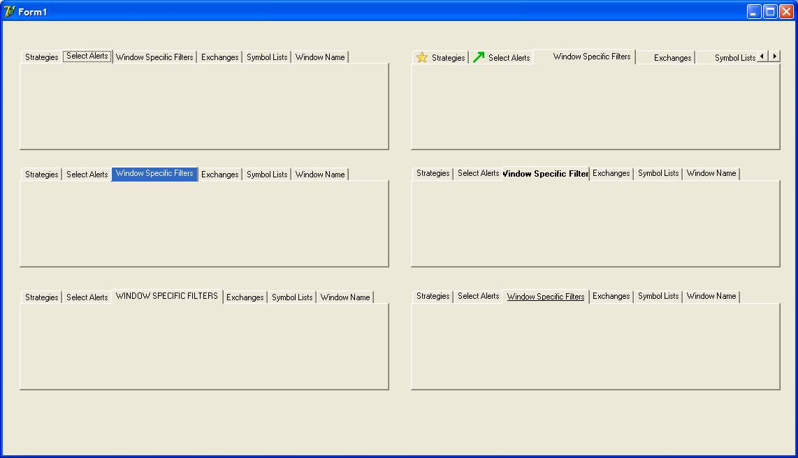
The picture above is a prototype showing several options. The second item in the left column is the new requirement. Whatever tab the user selects will Highlighted property set to true. Note: This applies to the initial selection, any selection that the user makes, and any selections that are made automatically in the code. (Hitting the OK button sometimes selectes the Window Name tab.)

Note: I like the option on the bottom right. At this time the requirement is only what I described in the previous paragraph. I’ve copied the code for the item on the bottom right, just in case we ever make this an option.

procedure TForm1.PageControl5DrawTab(Control: TCustomTabControl;
TabIndex: Integer; const Rect: TRect; Active: Boolean);
Var
ToDisplay : String;
TextSize : TSize;
C : TCanvas;
begin
C := Control.Canvas;
ToDisplay := (Control As TPageControl).Pages[TabIndex].Caption;
If Active Then
C.Font.Style := C.Font.Style + [fsUnderline];
TextSize := C.TextExtent(ToDisplay);
C.TextRect(Rect, Rect.Left + (Rect.Right - Rect.Left - TextSize.cx) Div 2, Rect.Top + (Rect.Bottom - Rect.Top - TextSize.cy) Div 2, ToDisplay);
end;

Make the “About…” dialog box more flexible.
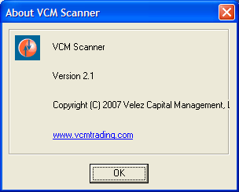
This is what I got when I set “CopyrightString=Copyright (C) 2007 Velez Capital Management, LLC”. Some of that got cut off because it was too long. We need some way to deal with this.

Use the custom icon on all dialog boxes.
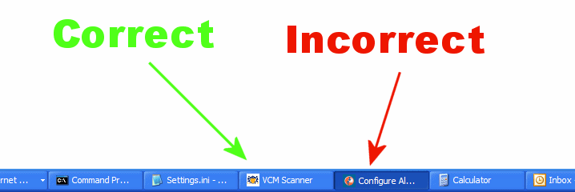
I customized the icon in TI Pro. In the above example, “VCM Scanner” is really TI Pro. The icon for the main program is correct. But when I bring up the configure alerts dialog box, you still see the normal Trade-Ideas icon. The same is true for the collaborate window and the history time frame window. These windows should use the same icon as the main program.

This only appears to apply to the dialog boxes that come from the ActiveX control. When the main program displays a dialog box, there is no separate entry in the task bar or the alt-tab menu.

Note: We already have code that is executed for every dialog box in the ActiveX control. We could add the fix in this code.

Further plans (version 2.2 and above) are moved to the "Plans for TI Pro 2008.doc" file.

